Debugging Procedures for West Port Project [2012/9/26]

Plans:
- Backup the current PecStar iEMS database.
- Upgrade the PecStar iEMS system.
- Update the Janitza Driver.
- Check if the Janitza Driver Energy (kWh) reading is tally with the Meter.
- Check if the formula data source is available to be shown in the PecTrend.
- SOPs on Reports.

Then follow these steps to fulfill the procedures.

Backup the current PecStar iEMS database. Follow these steps:
- Click Start -> All Programs -> PecStar V3.5 -> System Maintenance Module -> DatabaseManager.

- Click Backup on left list.
- Select the Source type and Destination for storing backup set. You can setup by default.
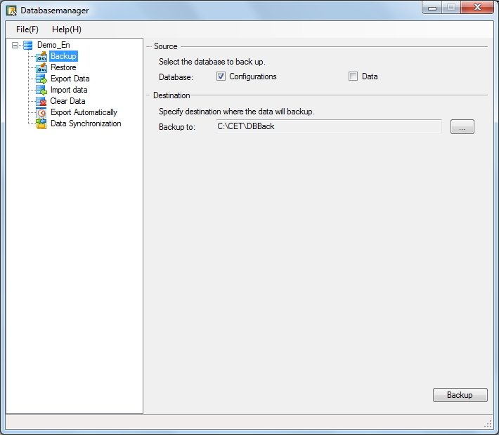
Source: includes configuration (refers to configuration database) and data (refers to historic database).

Destination: the path where the backup set locates. You can select to define the folder. The default path is in the CET\DBBack folder of PecStar iEMS
- Click Backup, input the user name and password on the User Login page. Then click OK.
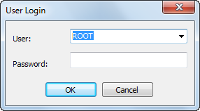

- Input the user info. with authority of Backup Historical Data. Click OK to proceed to the backing up process page.
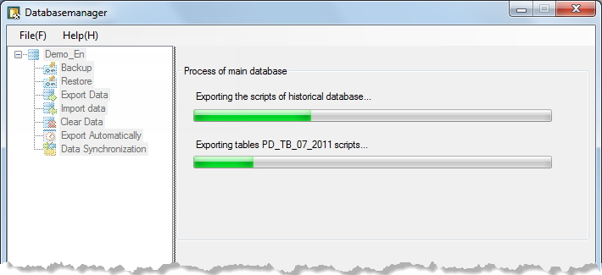

- Click Close after completed.
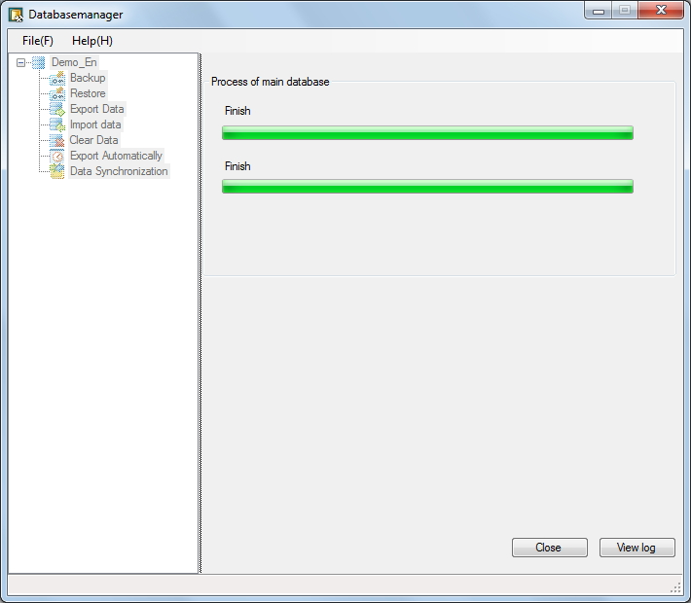

- After backup, these .BAK files will be generated in the CET\DBBack folder.
PECSTAR IEMS_CONFIG_XXX_MAIN(Version)(Date Time).BAK
PECSTAR IEMS_DATA_ XXX_MAIN(Version)(Date Time).BAK

Take these files back, and they are useful when restoring.

Upgrade the PecStar iEMS system. Please follow these steps.
- Before you update the PecStar iEMS, please ensure that:
- A valid license, e.g. the existent authorization files or dongle.
- Well functioned PecStar iEMS system and SQL Server connection.
- Gets the latest version of PecStar iEMS.

Download the newest PecStar iEMS V3.5 Install Package from：
http://www.adrive.com/public/YHKnJ3/PECSTAR35_Install_Package(20120924).rar
Copy the Package on the Server.

- Ensure that no other programs are running. Save your work and close any open applications of PecStar iEMS.

- Double-click setup.exe of PecStar iEMS install package to start upgrading.
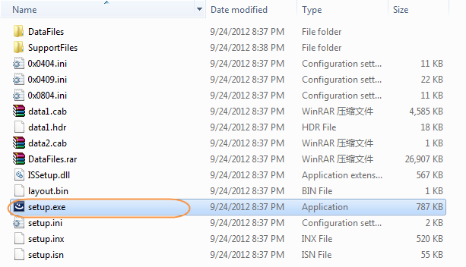

- The installer will check if lower version PecStar software has been installed. Click Yes to update the current system.
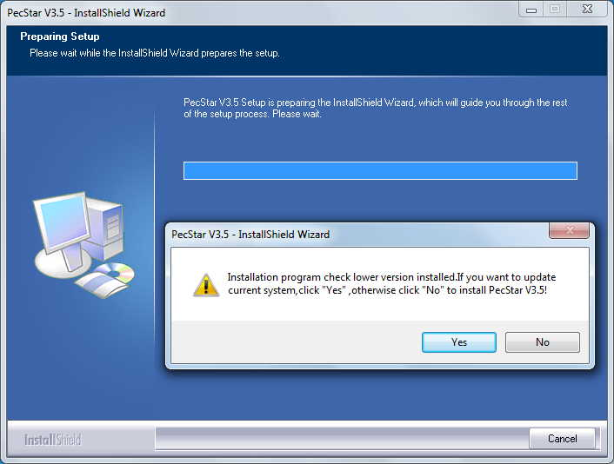

- Click Next on the Welcome page.
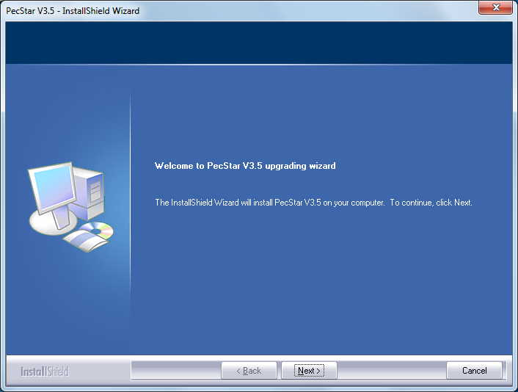

- Select the authorization mode, and click Next.
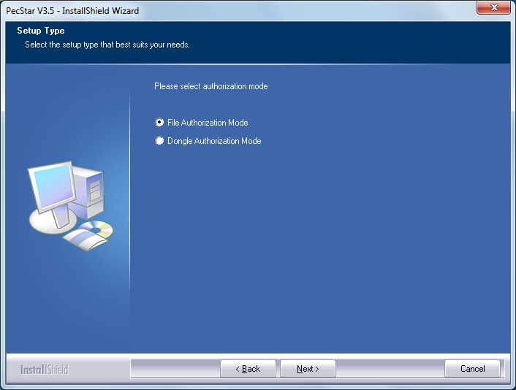

- For File Authorization Mode, PecStar will offer you the Computer Characteristic Information as follows. Send this to CET Electric Technology (xxx@cet-electric.com) to get the corresponded authorization file (swlic.dat).
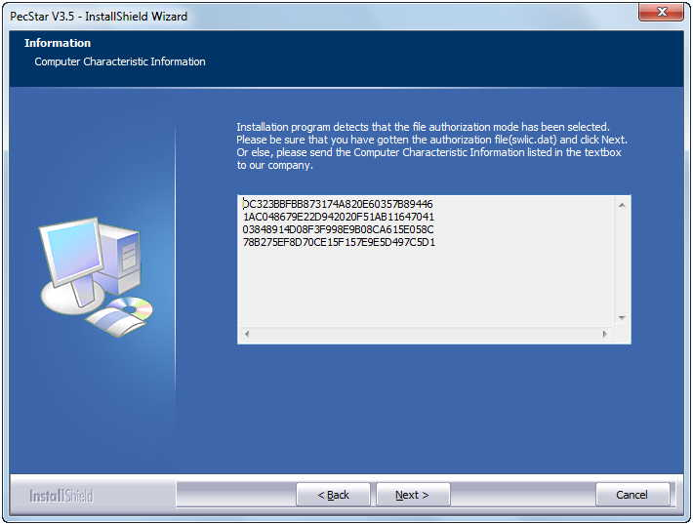

- Click Next on the Check Running Environment page if all components are installed.
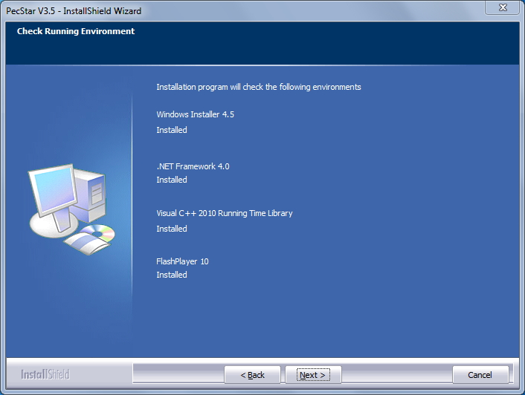

- Enter the Config Info. and click Next to proceed to Software Verified Info. page.
- For File Authorization, input the Serial Number and Authorization File Path (swlic.dat).

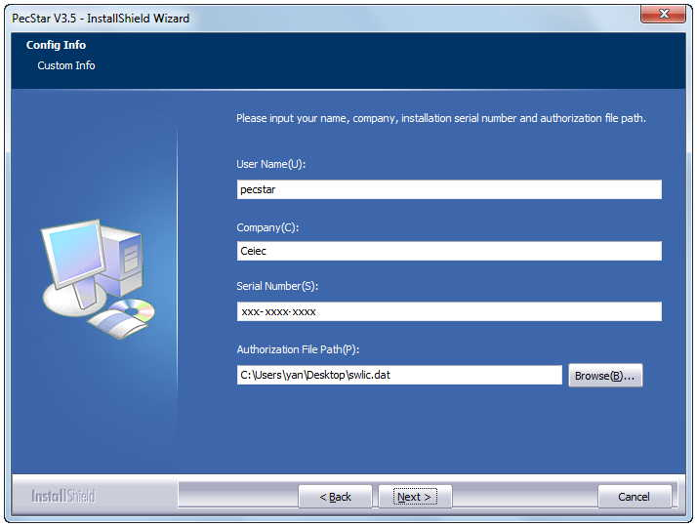

- For Dongle Authorization, input the Serial Number and Password of the dongle.
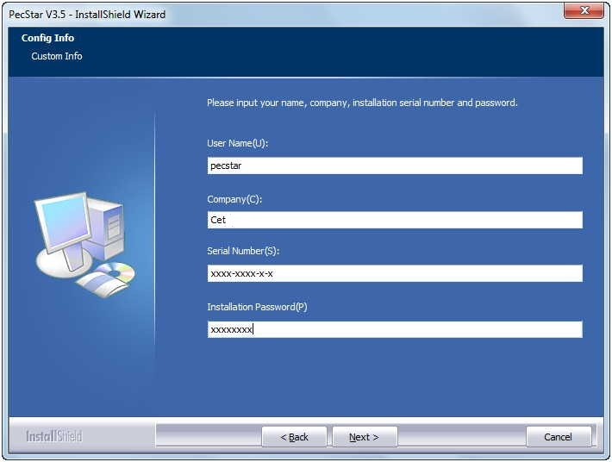

- Verify the information and click Next to proceed to the Confirm version info. page.
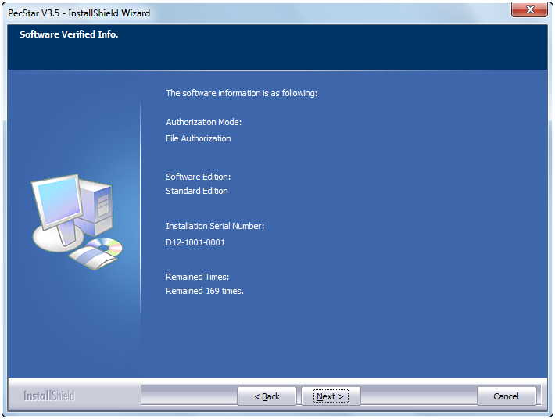

- Verify the upgrading information on the Confirm version info. page. Click Next to proceed to the Start to upgrade page.
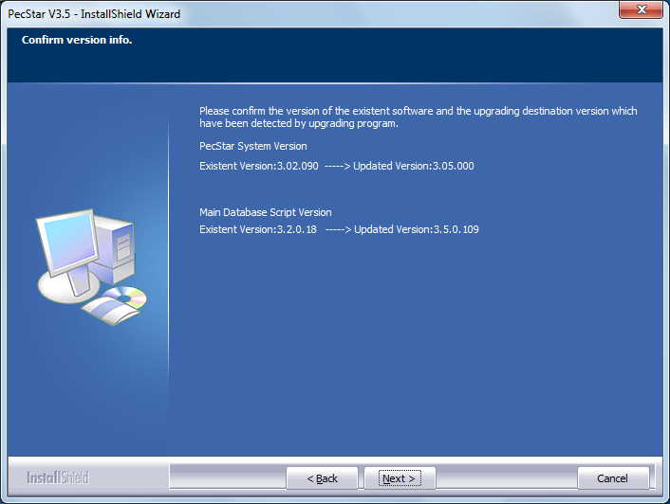

- Click Install to start PecStar Upgrading.
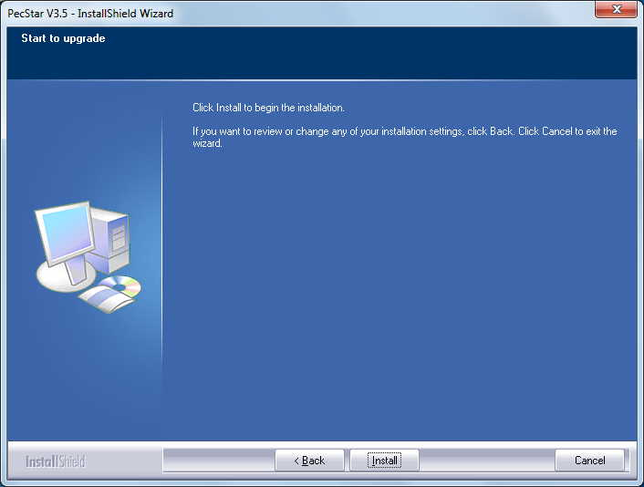

- Select whether to upgrade the datalog, and set the time range if necessary.
Input the IP address of computers listed. Click OK to continue the updating.

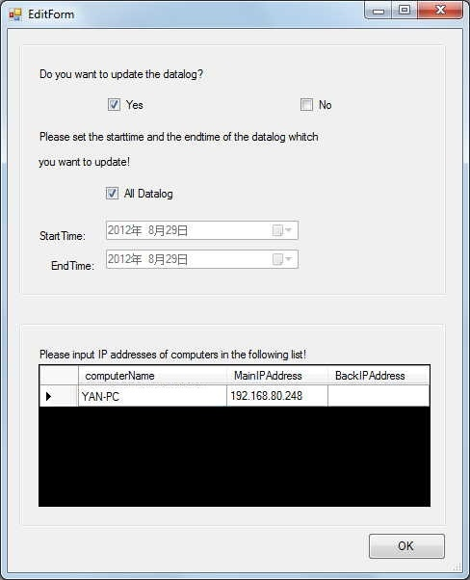

- PecStar will display some features during upgrading.
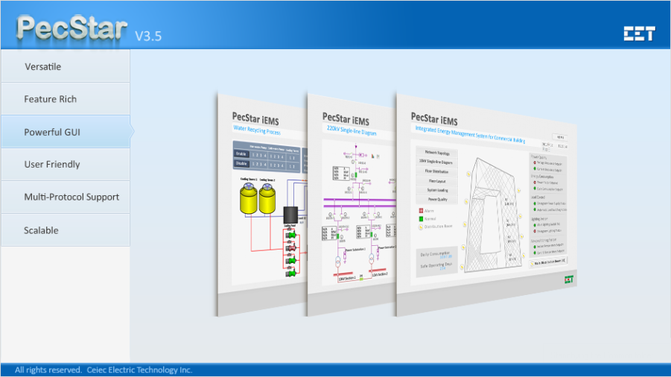

- Wait until the updating completes and click Finish.
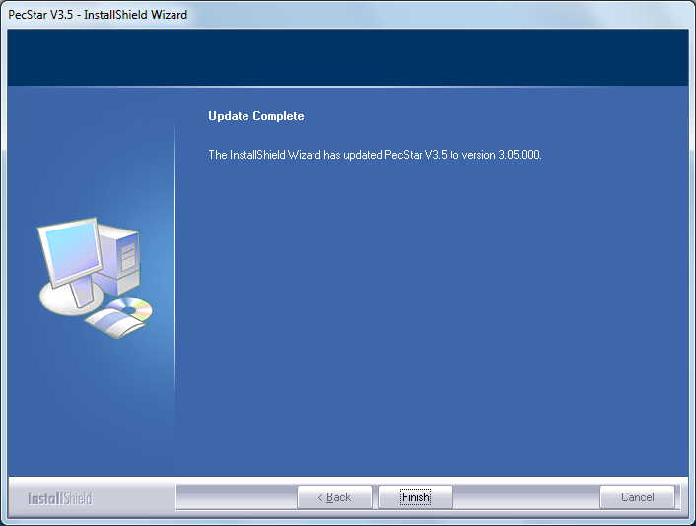

Update the Janitza Driver.
The driver has been updated the driver, so skip to the next step to check the values.

Check if the Janitza Driver Energy (kWh) reading is tally with the Meter.
Check if the Comm. parameters is tally with the PMC-1308’s?
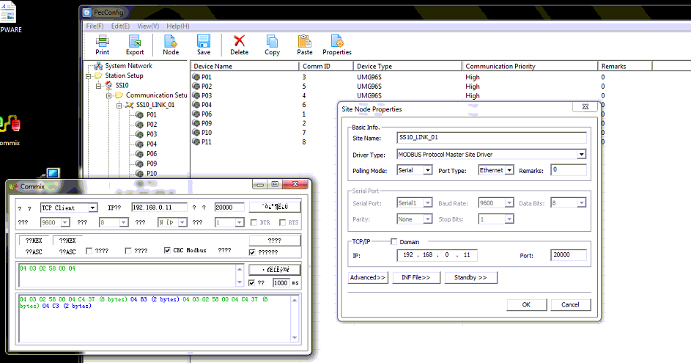

Steps:
- After the upgrading, click Start -> All Programs -> PecStar V3.5 -> Data Acquisition Module -> Front, and check if KWh values are corresponded with the ones shown on the meter.
- If the values are not tally with the Meter, please send the accurate values from both the Meter and the Front. We will plan to modify the program according to the results.

- Check if the formula data source is available to be shown in the PecTrend.
Solution:
- The upgraded PecStar iEMS package is mainly used to fix this problem. (You’ve mentioned that logging for formulae is available but no data source list for reporting. I can see the data on trending chart shown in Report West Port2.)
- After Upgrading the PecStar iEMS, start the PecTrend to check whether you can use these formula source in the reporting.

Other SOPs on Reports and Maintenance.
Please see below about the settings you’ve mention in e-mail.

Report West Port screen capture shows there is no data aggregation selection for energy data source, how can we sum the energy consumption in single cell?
Situation: I would like to show the total consumption of OffPeak and OnPeak.
Solution: How about adding a formula in another cell to show the sum value.
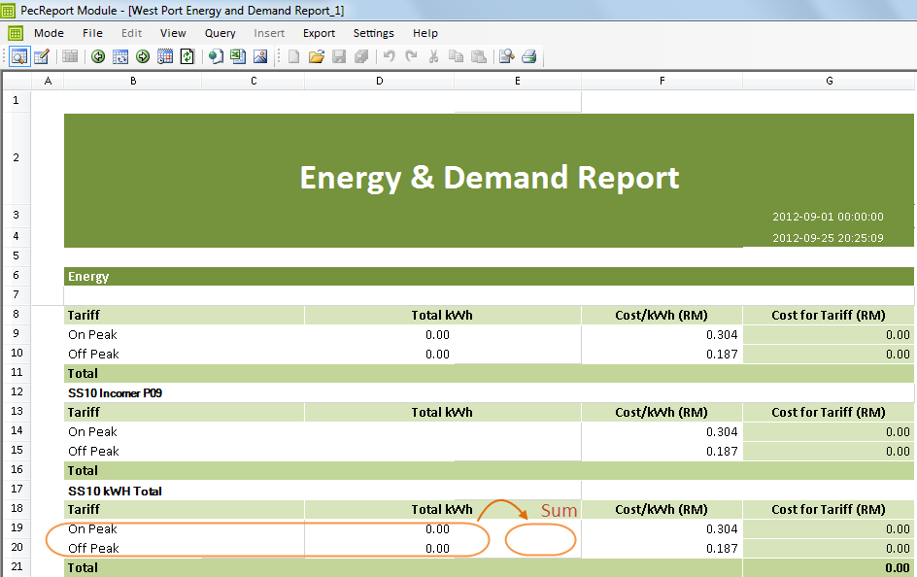

Follow these steps.
- Switch to the Edit Mode, select a cell and right click, select Grid Data Link.

- Click Combination Formula on the Data Link page.
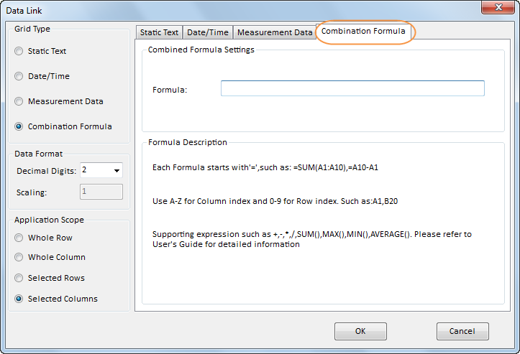

- Input the formula into the blank. For example, “=D19+D20” means this cell will show the sum values of D19 (On Peak) and D20 (Off Peak). Then click OK to finish the setting.

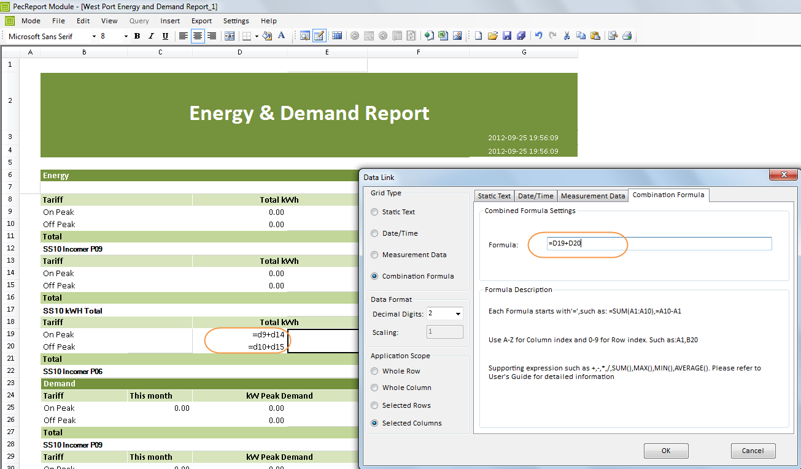

- Here displays the formula of this cell. You can modify the Font and Background.
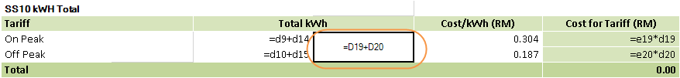

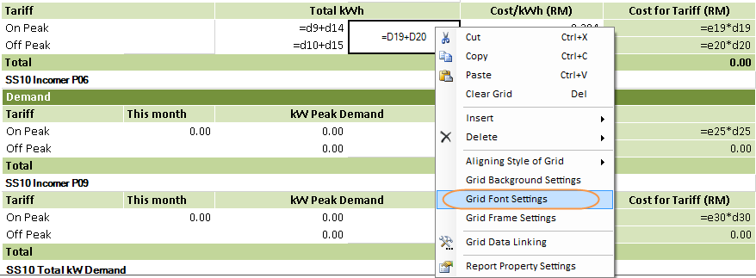

- Click the Save button on the toolbar.
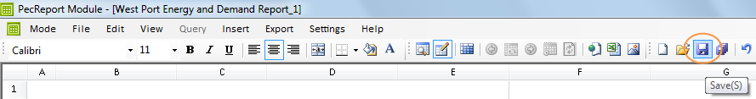

- Switch to the Querying Mode and Open the report.
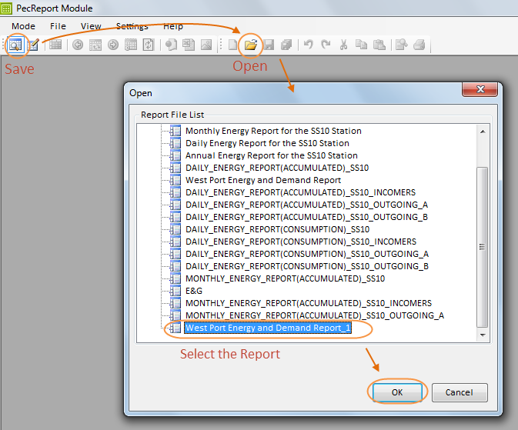

- See the results.

SOP of Switch over current PC from server to client (IF Server unable to perform due to certain circumstances)
Solution:
- If the Server and Client work separately without any connections, it is recommended that you backup the database of the Server and get a PecStar iEMS V3.5 install package. When it is necessary for the Client to run PecStar iEMS, install PecStar iEMS and then restore the database from backup.
Remember to open PecConfig on the Client computer, modify the computer node name and IP Address.
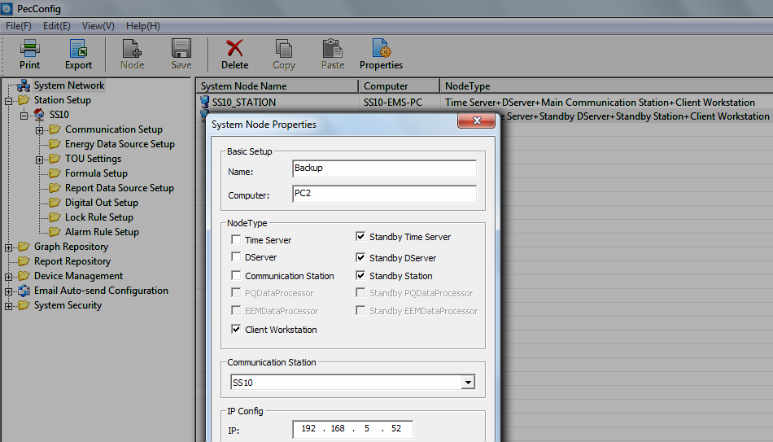

- If the Server and Client are in the same network and host as redundancy, you can backup the database of Server and restore to the Client, and configure the redundancy settings as follows:
- After restore the PecStar iEMS database from Server to Client, first of all, open the PecConfig program on Client. (Click Start > All Programs > PecStar iEMS iEMS V3.5 > System Configuration Module, select PecConfig.)
- Add a system node of the Client. Input the Computer name, IP address of the Client, and select the standby node types as follows:
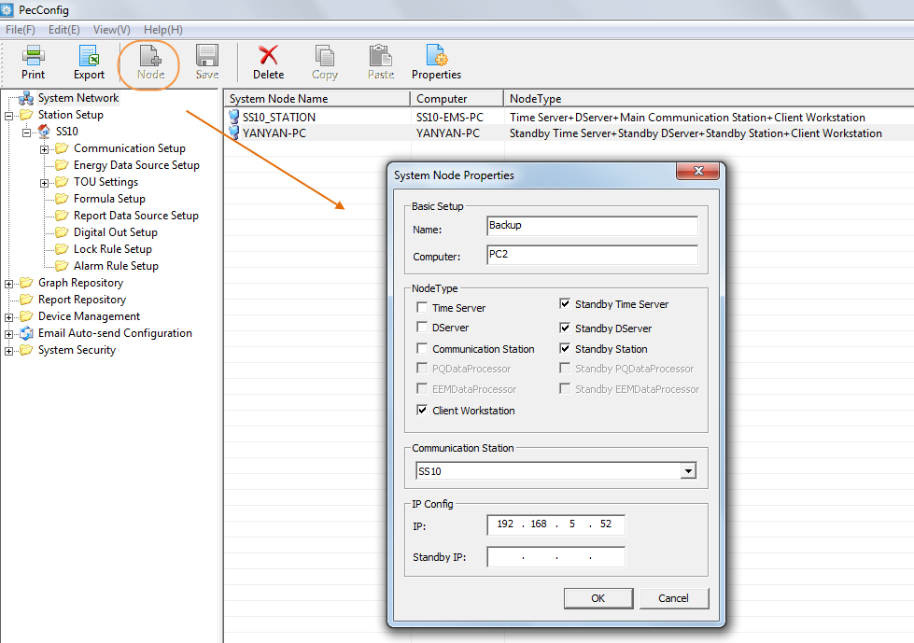

- Click Save to store the configuration into the database.
- Double-click the DatabaseConfig program in CET\Common path.
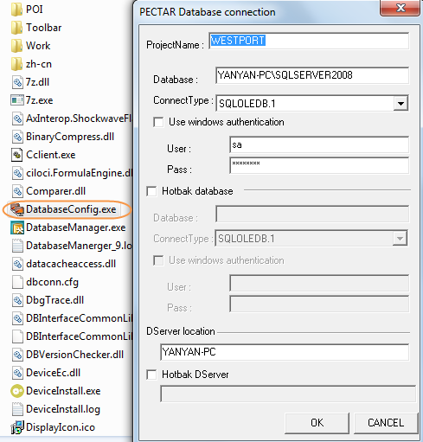

- Click the Hotbak database, input the database name, and the SQL Server authorization information (user name and password) in the blanks.
- Click the Hotbak DServer if you setup the Client computer as the standby DServer in PecConfig. Input the computer name of the Client. Click OK to save the configuration.
- Next, you are able to run the PecStar iEMS on the Client computer hosting as a standby. The Client will automatically become the Main Server when the Server’s communication goes wrong.

Report West Port1 screen capture shows logging for formulae is available but no data source list for reporting. I can see the data on trending chart shown in Report West Port2.
Solution: This has been fixed in the newest package. Please see the details above, download the PecStar iEMS V3.5 install package and upgrade for the current system.

SOP for migrating the system to actual Server.
Steps:
First, you may need to backup the current PecStar iEMS system. Please see the details mention above. And then, when you want you migrate the system to another computer, you can follow these steps to restore a PecStar iEMS database from a backup:

- Choose the appropriate database that you restore the data into.
Follow the same directions as those for backing up PecStar iEMS database.

- Stop all programs of PecStar iEMS and SQL Server. Don’t forget to exit the Dserver program in the Windows Taskbars.

- Start the DatabaseManager program, click Restore on left list. The Restore settings appear.

- Select the Source type and Destination of backup set for restoring, check the box for appropriate backup set to be restored.
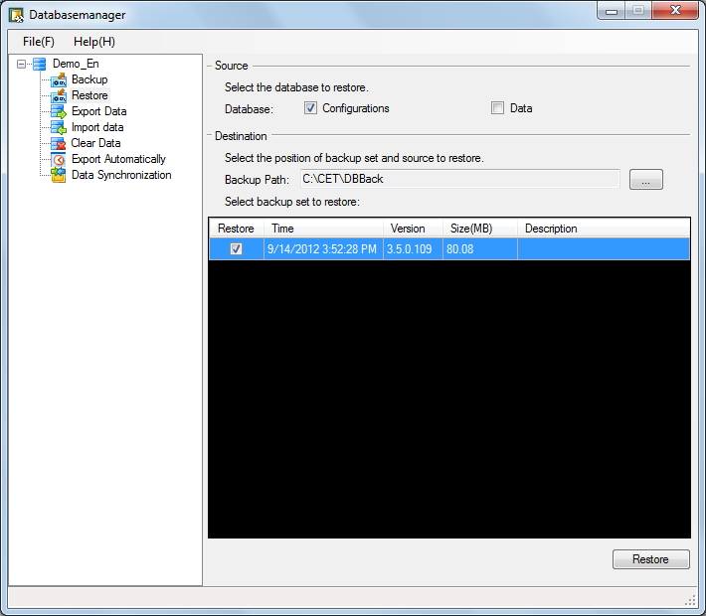
Source: includes configuration (refers to configuration database) and data (refers to historic database).

Destination: the path where the backup set locates. You can select to find the files.
- Click Restore, then the User Login page appears.
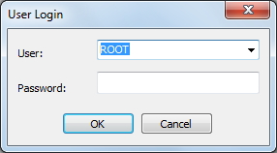

- Input the user info. with authority of Backup Historical Data. Click OK to start restoring.

- After completed, click Close to exit or View log for details during restoring.
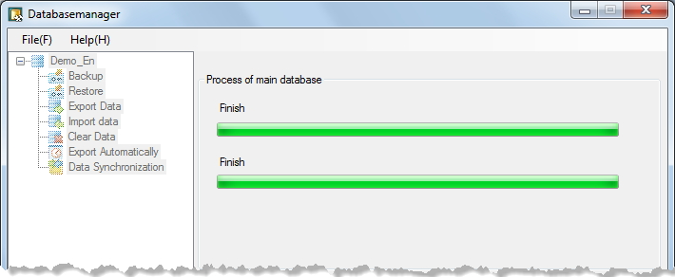

- Then you can open the PecConfig to setup network nodes of the database.

